JDBC Practical

Java Database Connectivity (JDBC) is the Java API that allows client to connect and execute the query with the database.

MySQL Workbench

Student details such as id, name and department are stored in database.

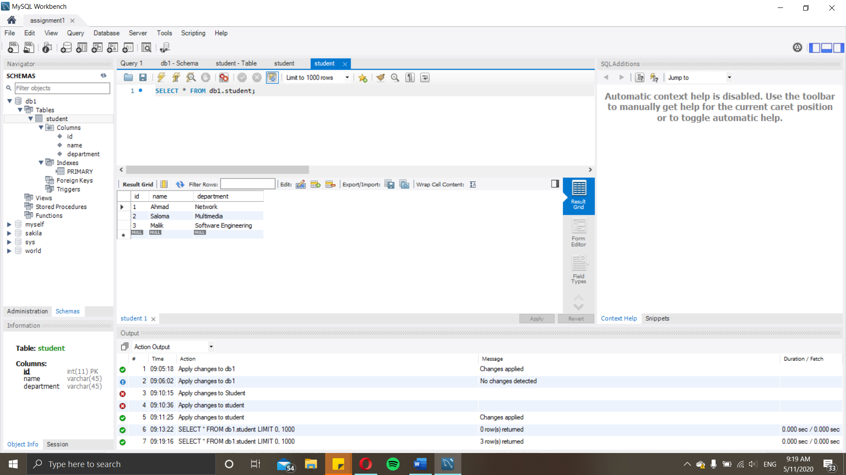

Coding

The program is written in Java that allows students’ information to be retrieved from the database by accessing with JDBC. Output after the program is run as shown in the console.

